Willian Bernatzki Woellner

30021175

Testing Documentation

AT2

Table of Contents

Application Testing Documentation 1

Screenshots 3

# Application Testing Documentation

|  |  |  |  |  |
| --- | --- | --- | --- | --- |
| **Test Case** | **Description** | **Expected Result** | **Actual Result** | **Comments** |
| 01. Testing webpages load on different devices | Chrome used to load the various webpages on different devices using the device toolbar within the F12 menu. | Webpages load and display as normal, images or charts scroll correctly when devices with a screen size smaller than image or chart size. | All pages are loaded in different sizes, but there is a label (comment) on the Home page. | Ref. Figure 1  Ref. Figure 2  Ref. Figure 3 |
| 02. Searching for a movie by Title. | Searching the database for a movie only using the movie title. The search term is in the database. | Table to be shown with search results. | As expected | Ref.Figure 4  Ref Figure 5 |
| 03. Searching for a movie by Genre. | Searching the database for a movie only using the movie Genre. | Table to be shown with search results. | As expected | Ref. Figure 6  Ref. Figure 7 |
| 04. Searching for a movie by Rating. | Searching the database for a movie only using the movie Rating. | Table to be shown with search results. | As expected | Ref. Figure 8  Ref. Figure 9 |
| 05. Searching for a movie by Year. | Searching the database for a movie only using the movie Year. | Table to be shown with search results. | As expected | Ref. Figure 10  Ref. Figure 11 |
| 06. Searching for a movie by a combination of title, Year. | Searching the database for a movie using the movie Title and Year. | Table to be shown with search results. | As expected | Ref. Figure 12  Ref. Figure 13 |
| 07. Searching for a movie by a combination of Genre, Rating | Searching the database for a movie using the movie Genre and Rating. | Table to be shown with search results. | As expected | Ref. Figure 14  Ref. Figure 15 |
| 08. Top ten has been updated. | Checking to see if the top ten list has been updated with the extra searches. | The new top ten chart to be shown with different values based on the new search terms. | As expected | Ref. Figure 16  Ref. Figure 17 |

# Screenshots

Figure 1

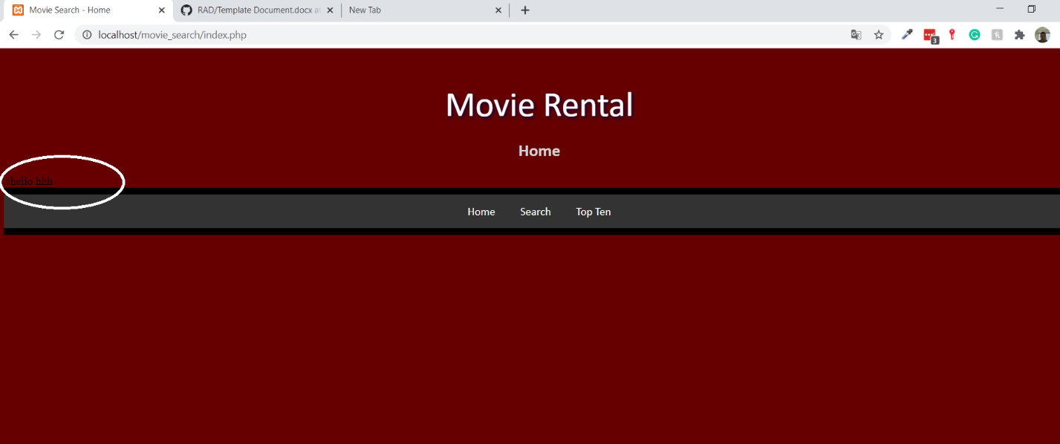

Figure 2

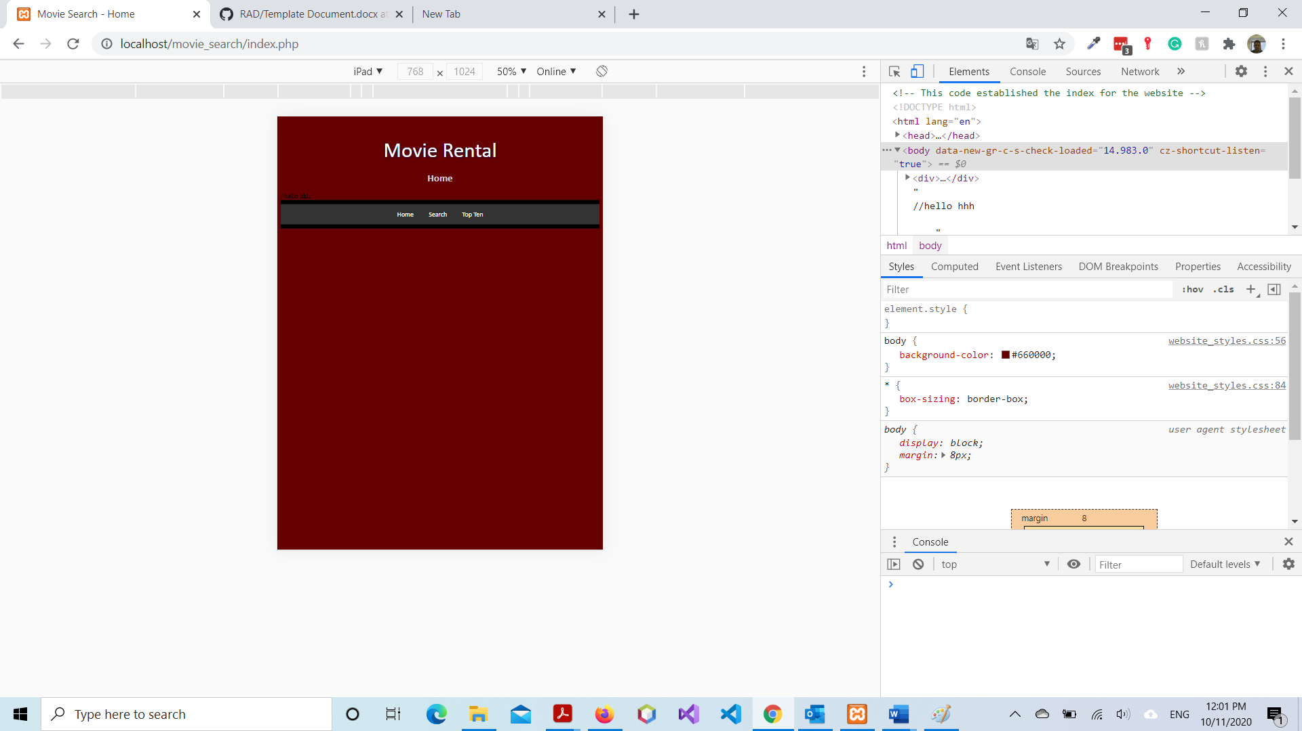

Figure 3

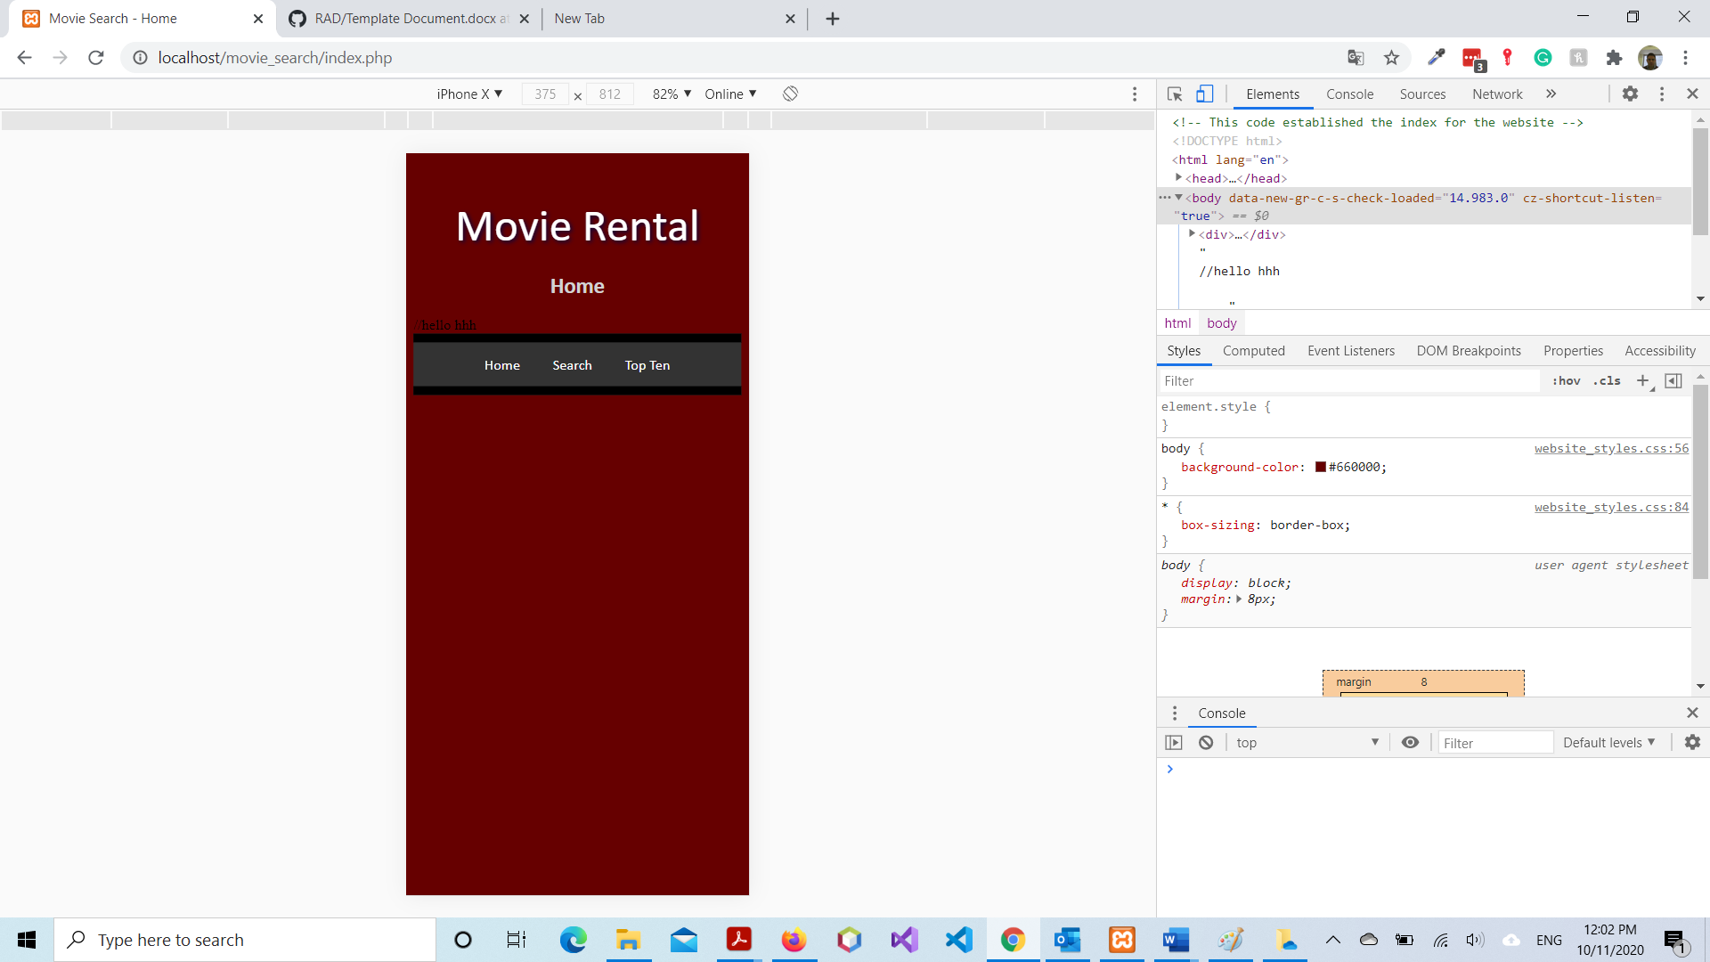

Figure 4

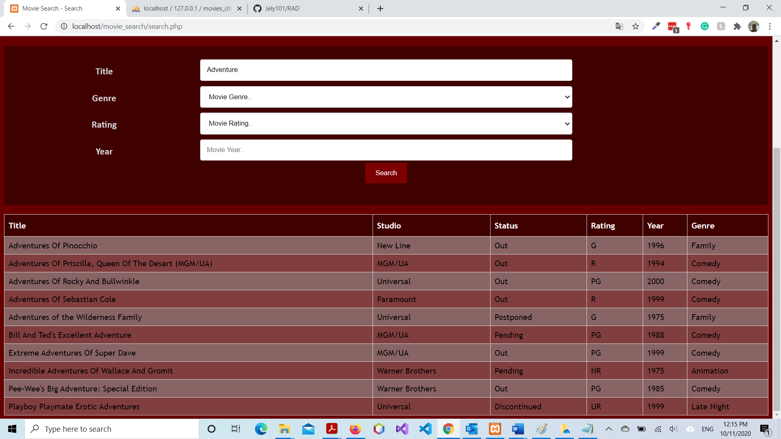

Figure 5

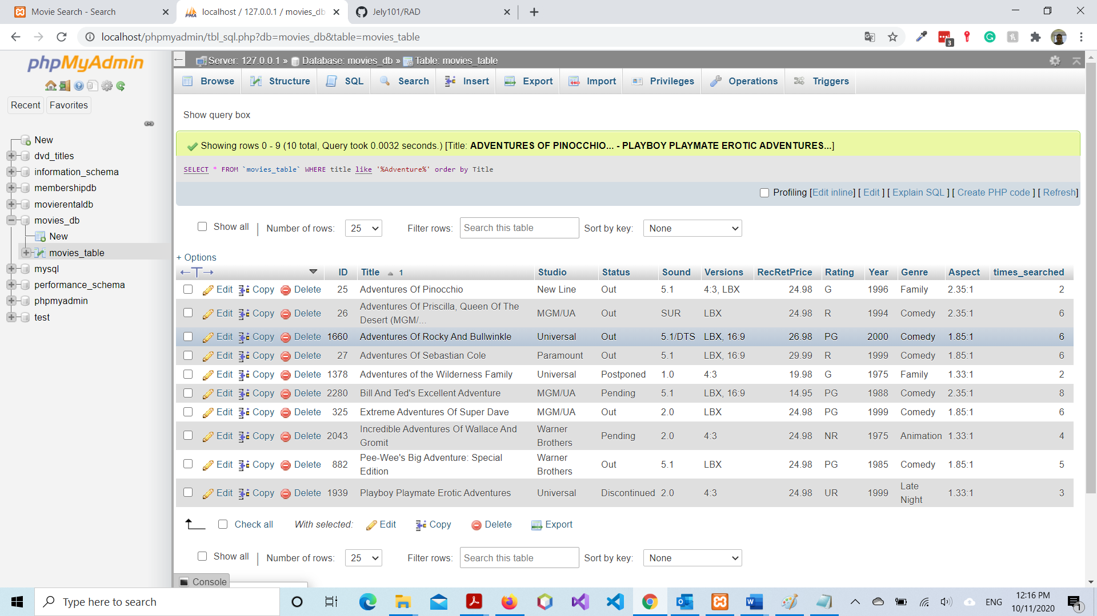

Figure 6

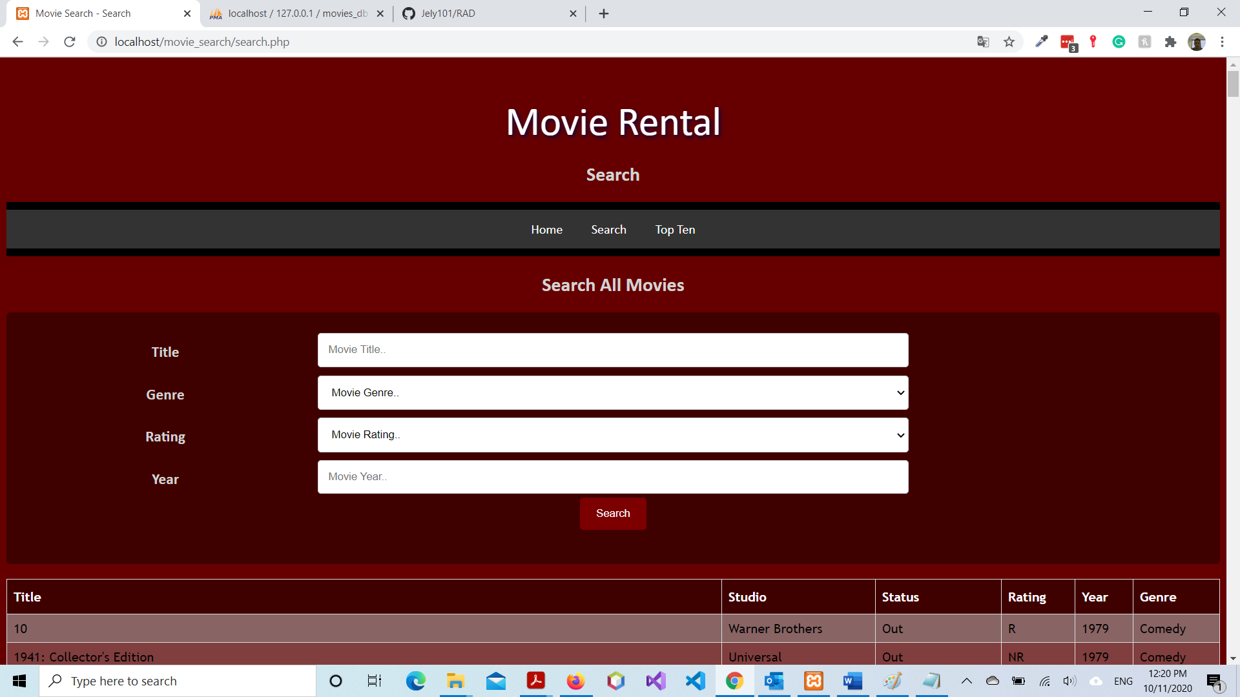

Figure 7

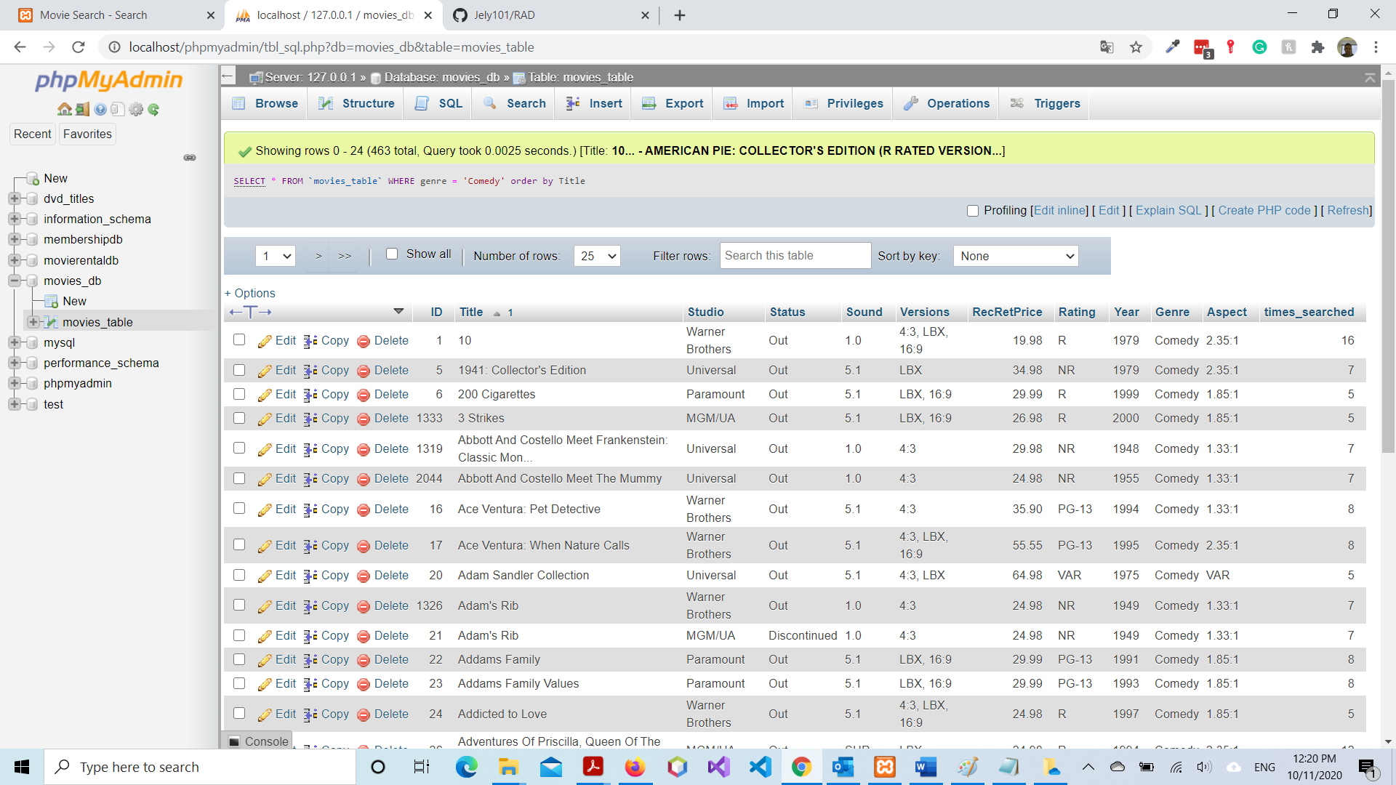

Figure 8

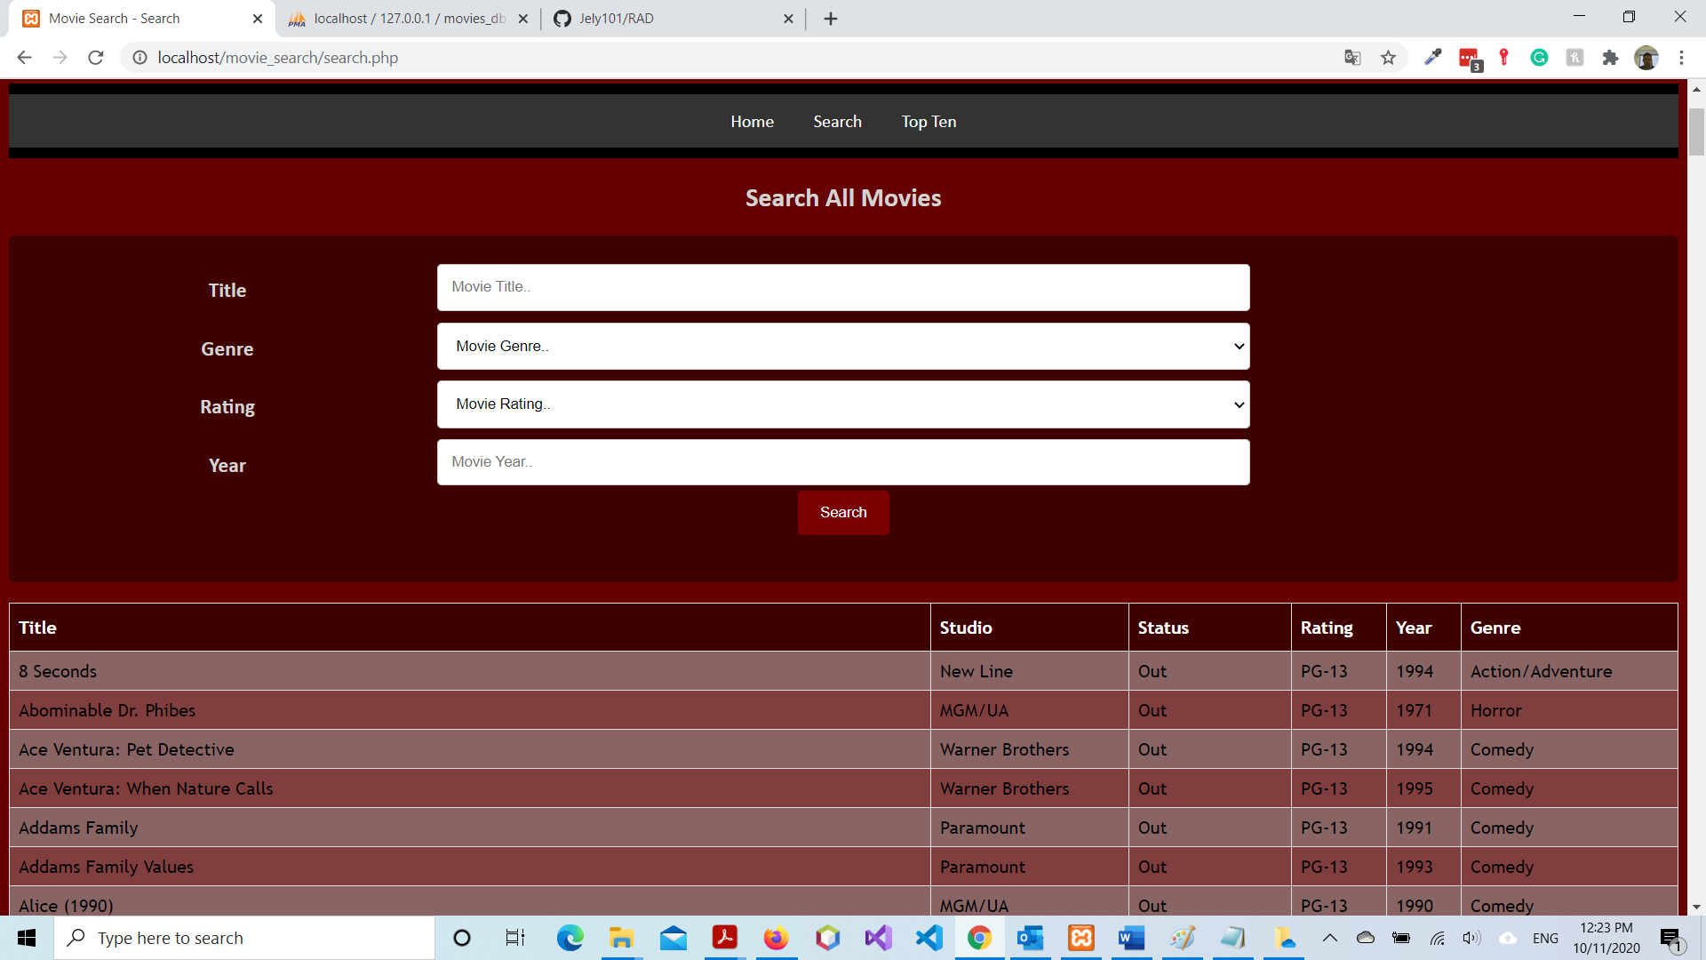

Figure 9

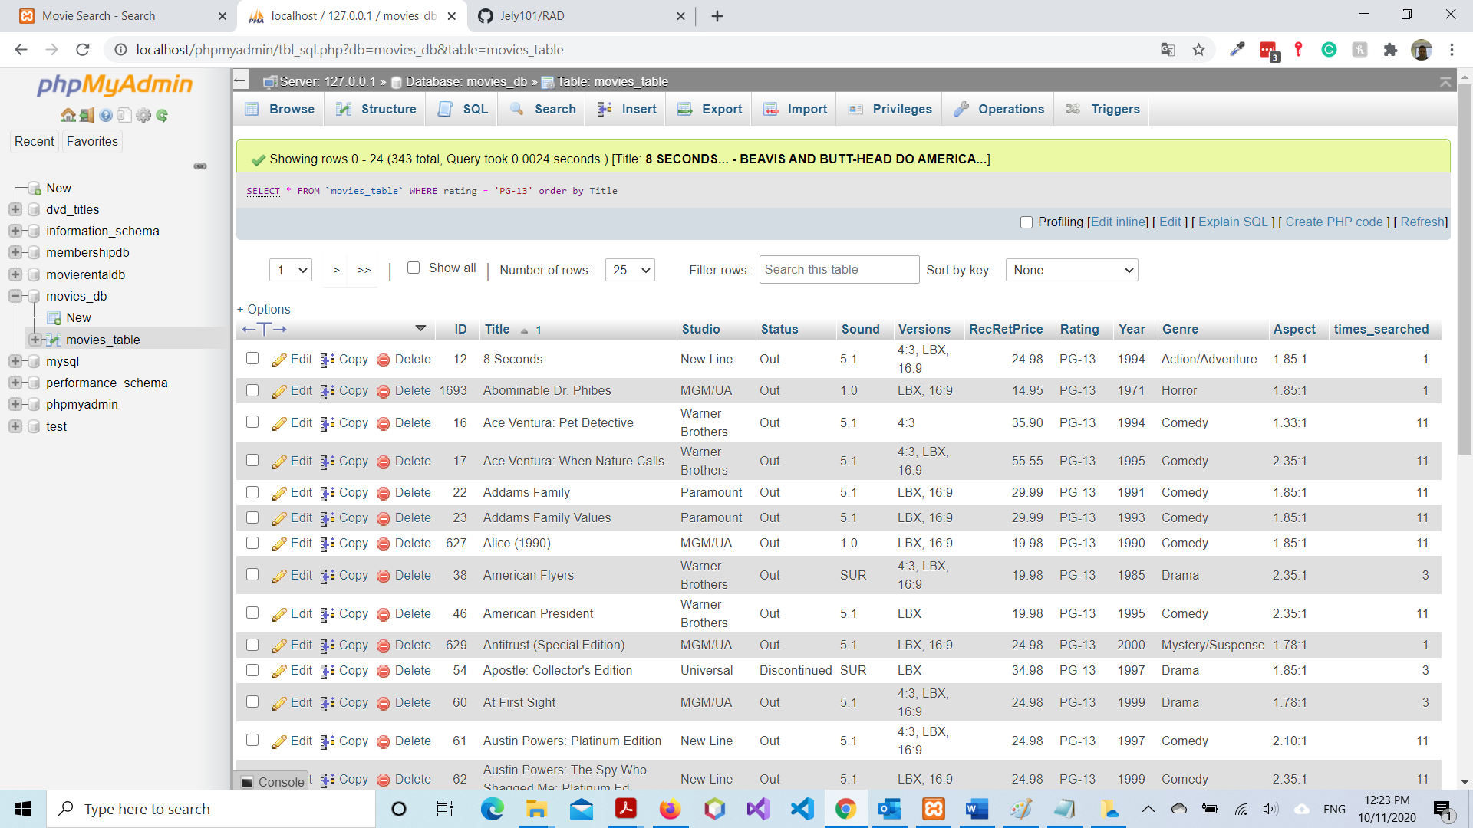

Figure 10

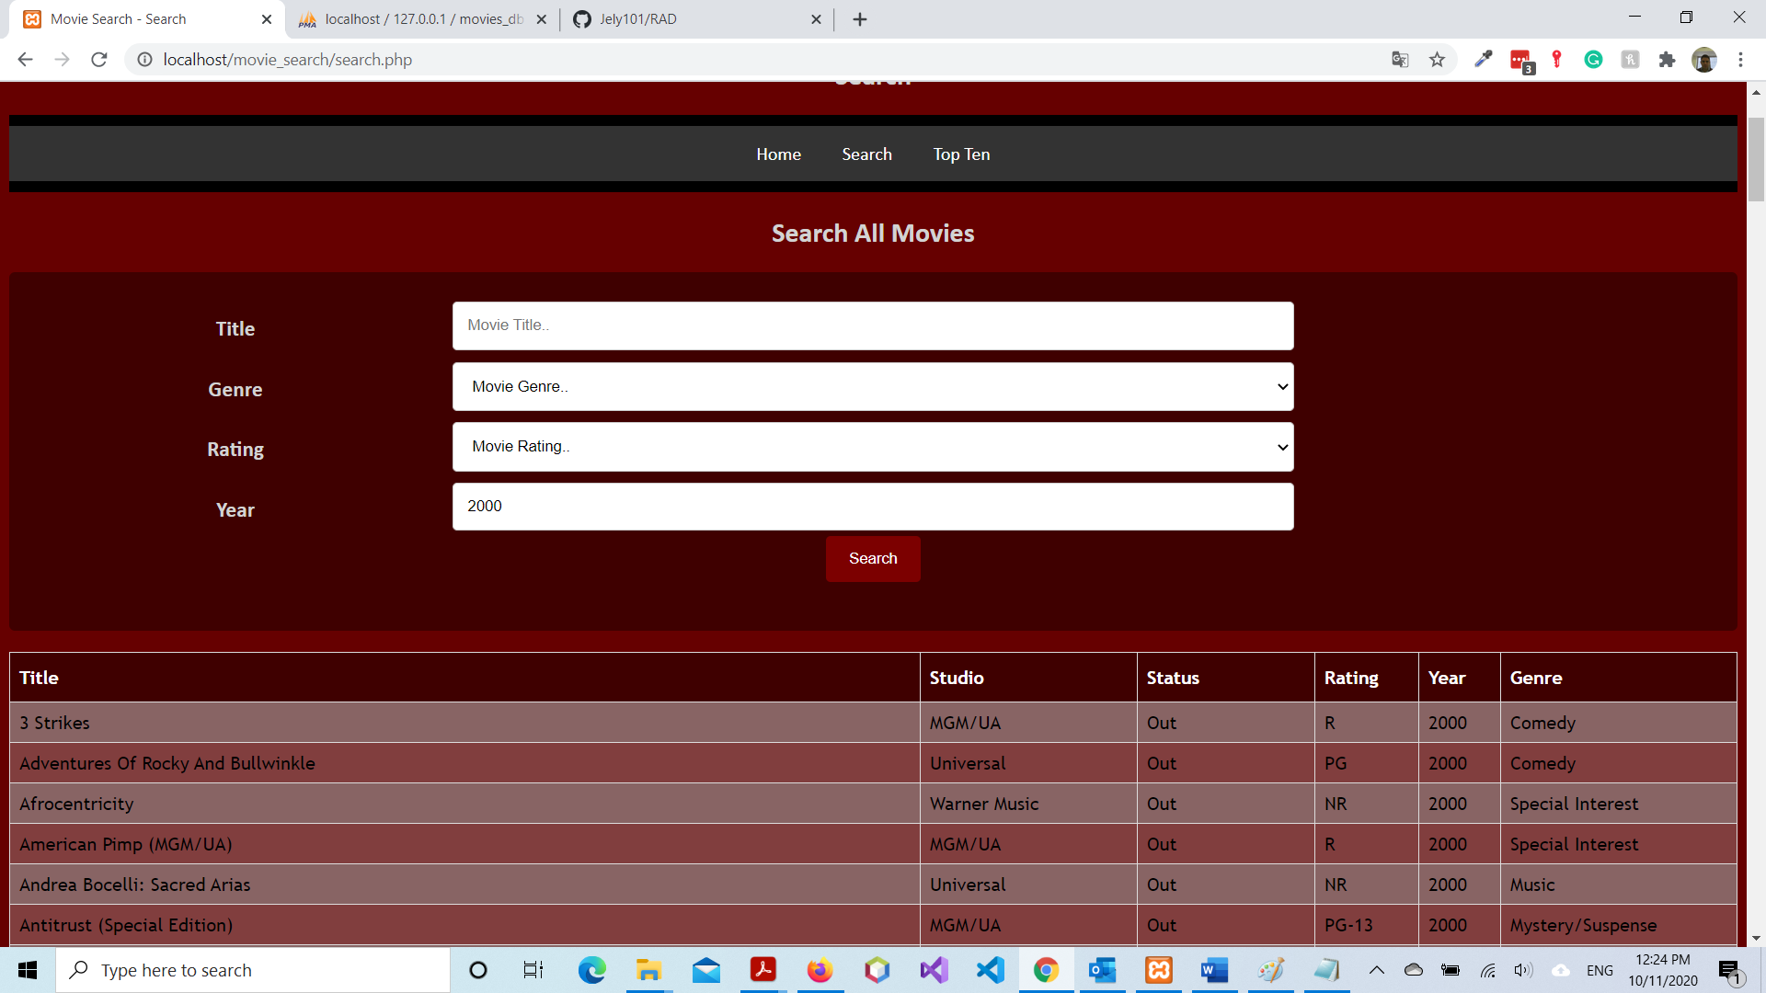

Figure 11

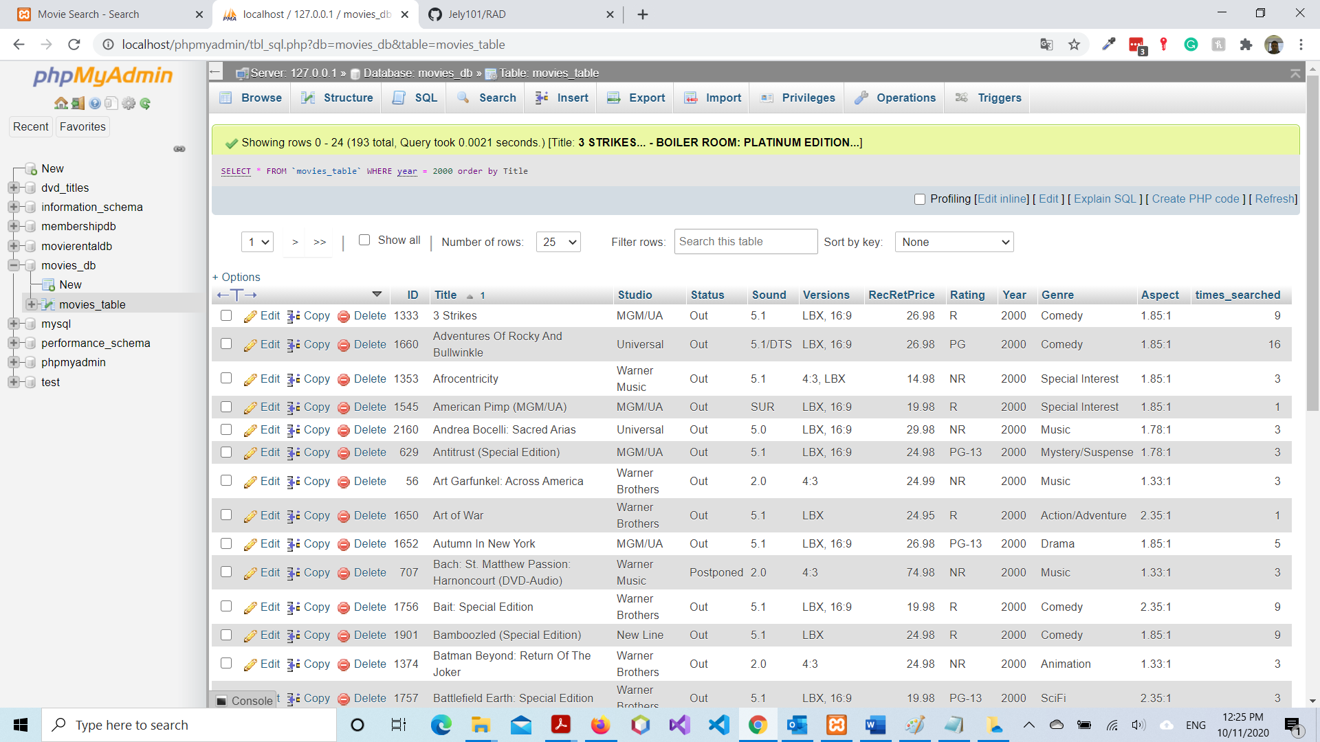

Figure 12

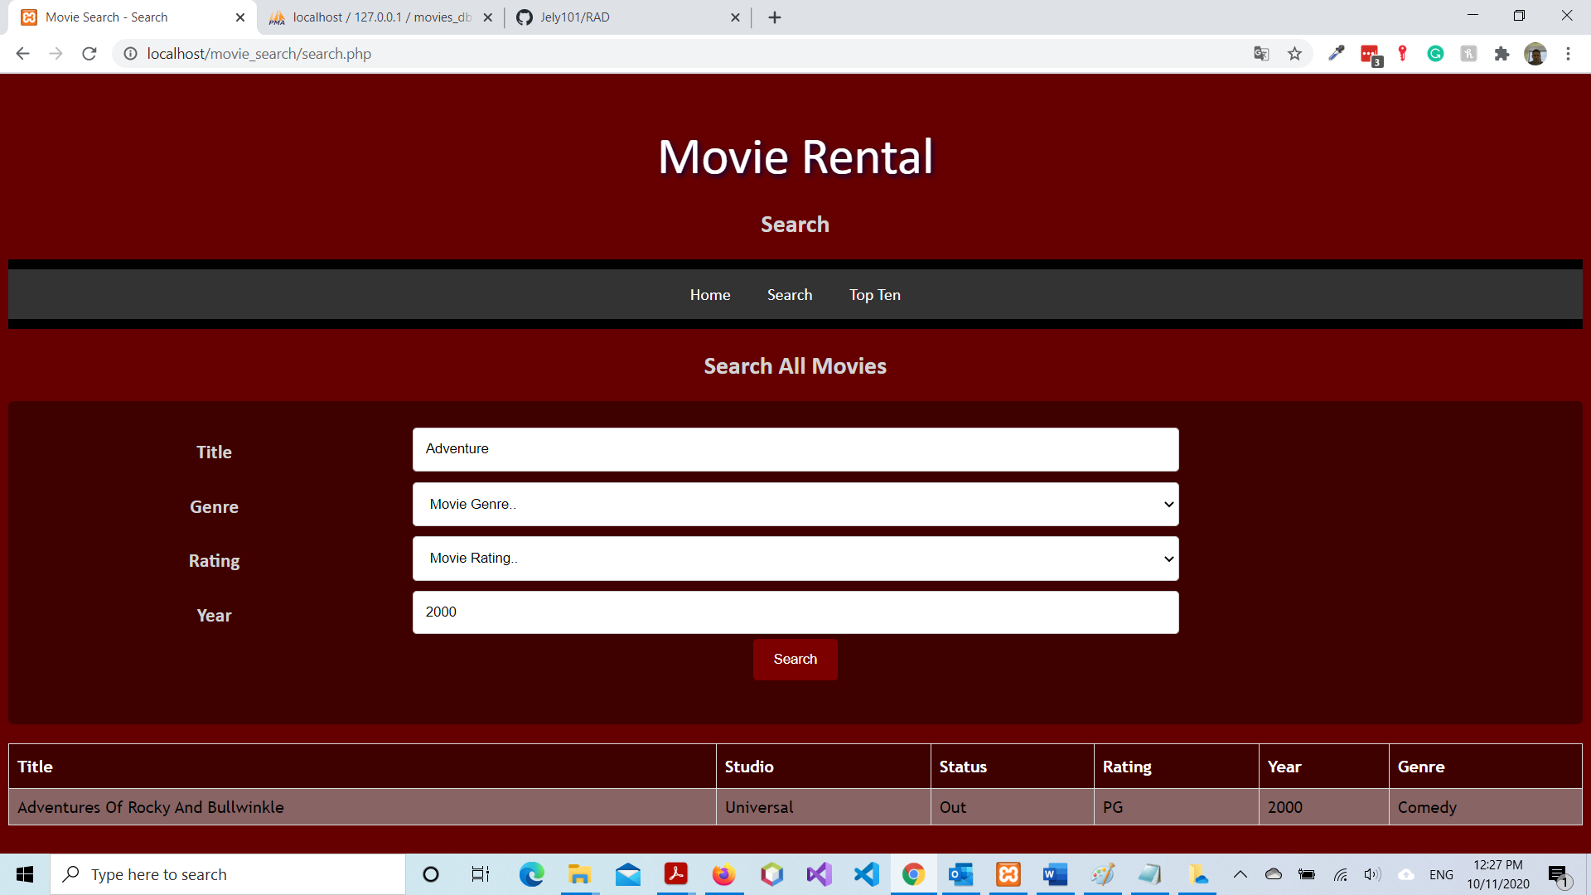

Figure 13

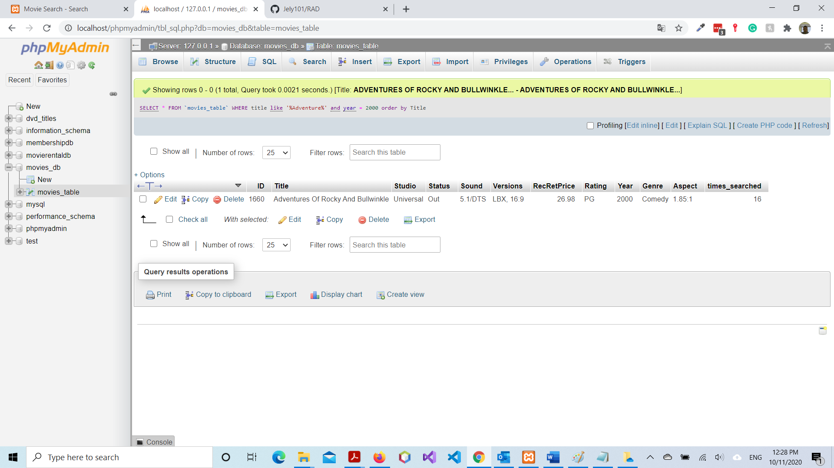

Figure 14

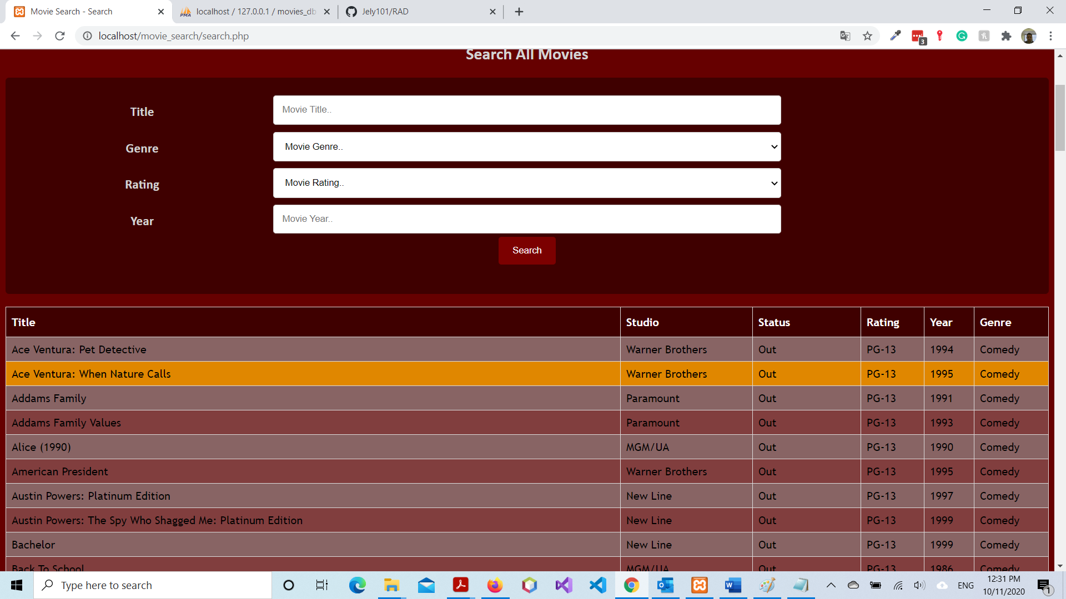

Figure 15

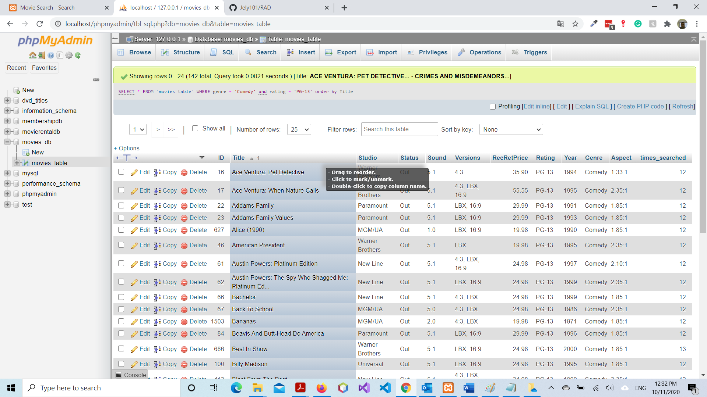

Figure 16

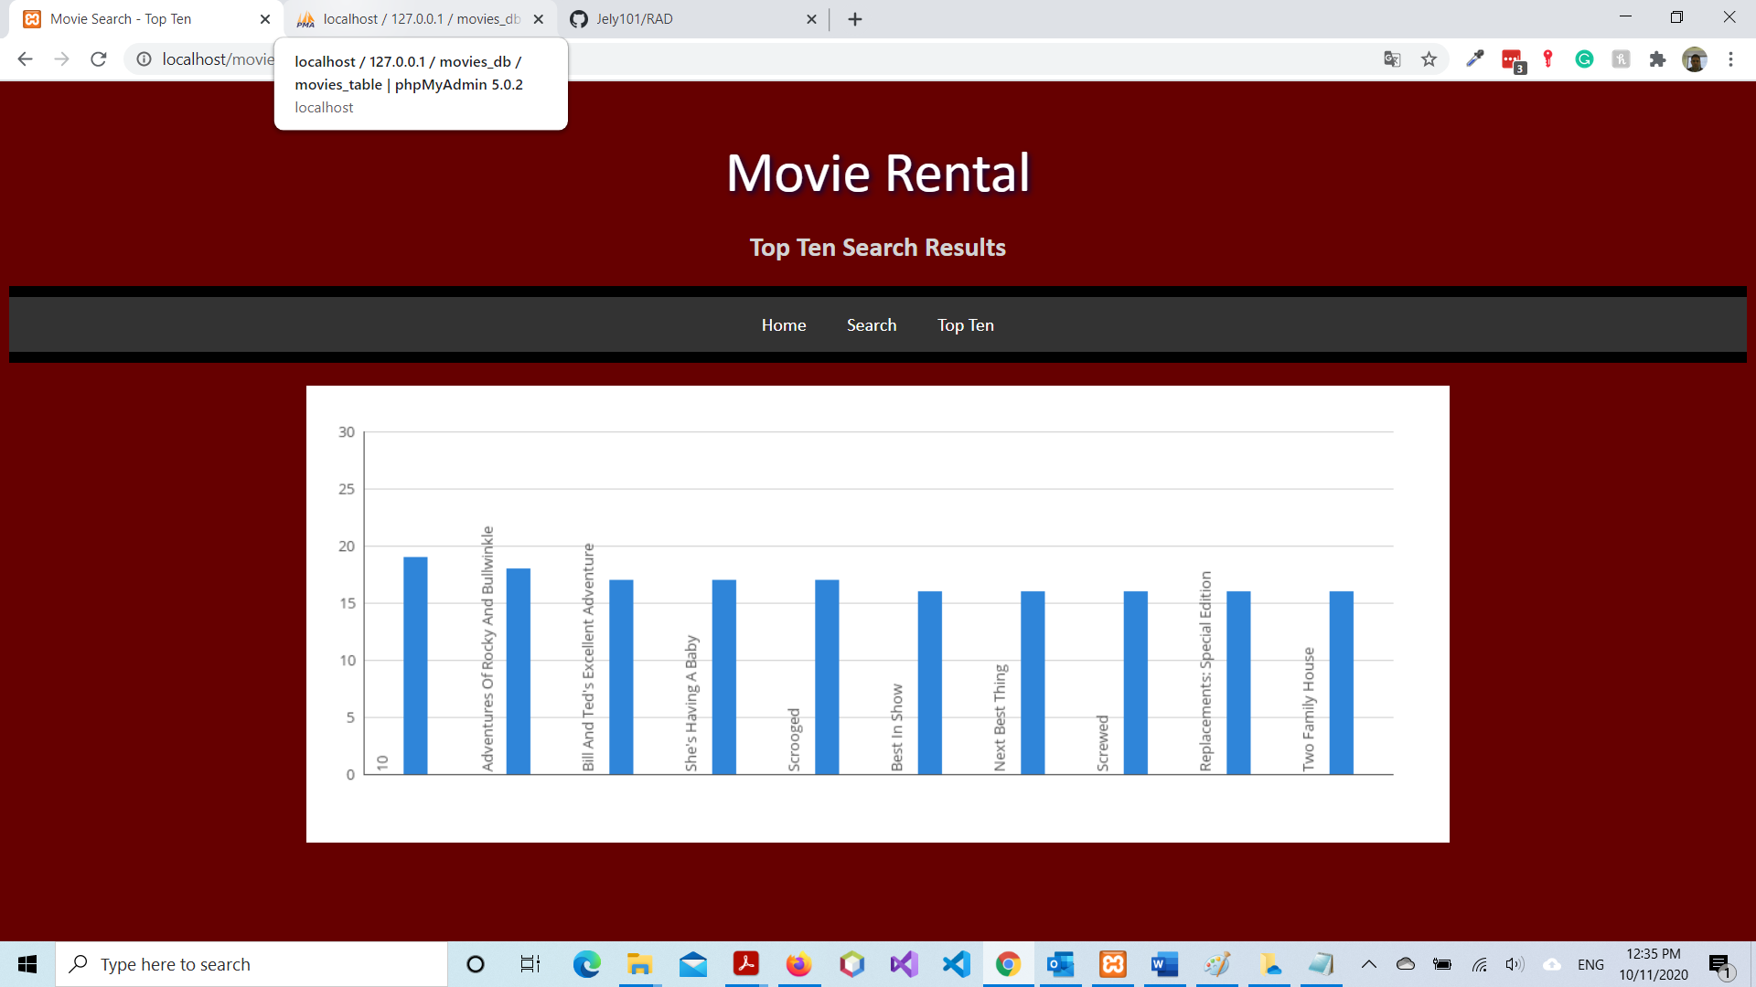

Figure 17

